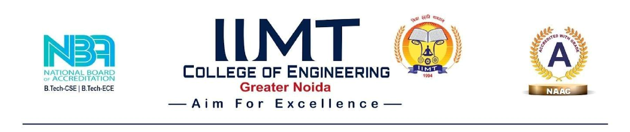

Ref. DO Date:

Sub: Smart India Hackathon 2026 – Nomination
I am pleased to nominate the below team from our college to participate in Smart India Hackathon 2026. AICTE Application No/ UGC Registration No for our college is 1-7435011.
Team Name:
 | Name | Gender (M/F) | Email id | Mobile no. | Stream | Academic  Year
Team Leader | PRINCE KUMAR | M | Princeswn4@gmail.com | 9334232437 | B.TECH(CSE AI) | 3rd
Team Member | UTSAW KUMAR | M | Utsawkumar867@gmail.com | 7292961601 | B.TECH(CSE AI) | 3rd
Team Member | PRASANG ANAND | M | Prasang.anand2007@gmail.com | 6203540217 | B.TECH(CSE CORE) | 3rd
Team Member | PRASHANT KUMAR | M | Prashantbgs023@gmail.com | 927988792 | B.TECH(CSE AI) | 3rd
Team Member | SAUMYA PANDEY | F | Saumyapandey5667@gmail.com | 7080711592 | AI DS | 1st
Team Member | JUNAID ALI | M | Junaidali8757@gmail.com | 7541829686 | AI DS | 1st
Sincerely,

Dr. Pankaj jha
SPOC-SIH
HOD ECE Department

